Smart Construction Theme Group (Digital and Offsite)
28th September 2021, 3.30-5 pm : A virtual meeting by Zoom
Registration link : https://us02web.zoom.us/webinar/register/WN_miPobJmYSE-2NNN_lM5RGg
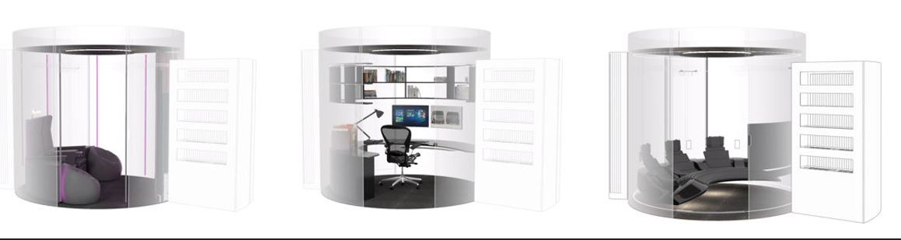
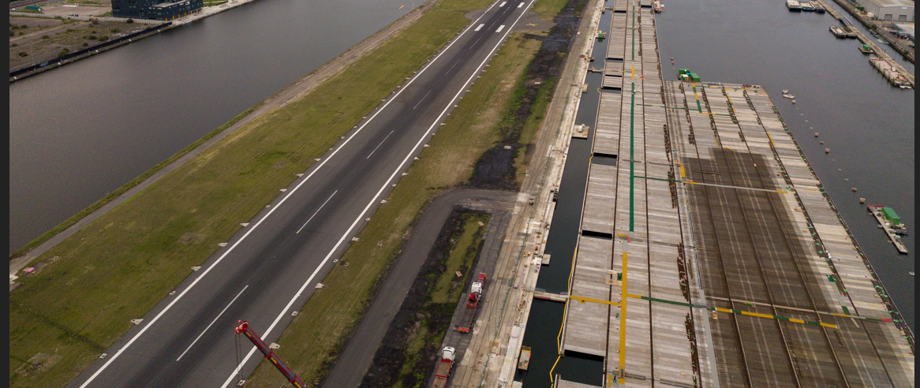

Constructing Excellence South West Smart Construction Forum in Partnership with Innovate UK
A session to showcase a number of the Transforming Challenge Projects funded by Innovate UK
Hear from participants of the Challenge, ranging from start-ups to housing associations, within the sector and outside. Find out more about the problems they were solving, and the vision their teams have for industry. Get involved in the shift away from cheapness, towards digital manufacturing, data and digital driven processes and whole-life value.
Introduction from Mary Bennell – Chair of CESW Smart Construction Challenge
The Challenge Projects : Chaired by Elspeth Finch MBE, CEO of IAND
Panellists:
• Future Joinery Systems - Configurable BIM Tools
• Walsall Housing Group and Birmingham City University - West Midlands DfMA
• My Global Home - Increasing Productivity Quality in Mass House Building
• Converge - Core
Q&A – your opportunity to find out how these investments can help your organisations.

Any questions : Contact mary.bennell@swpa.org.uk

